**Supplementary Material: Is it good to work with? Workability and the meaning of non-native species in urban policy**

**Table of Contents**

1. Figure S1 – Policy Document Examples 2

2. Table S1 – Cosine Similarities for Alewife 3

3. Table S2 – Generating the Dependent Variable 5

4. Figure S2 – Monitoring Document Example 7

5. Figure S3 – Merging Procedure 8

6. Sources of Texts 9

7. Decision Trees 9

Ecological Impact 10

Economic Costs to Industry 10

Profitability (1/0) 11

8. Supplementary Data: Alternative Biological Abundance Variable 12

9. Supplementary Analysis: Qualitative Evidence for Workability 13

Aquatic Animals in Comparison to Plant Biocontrol 13

Community Events and Herbicides are Workable Solutions for Invasive Plants 14

Emerald Ash Borer and Asian Long-horned Beetle 16

Examples of High, Medium, and Low Species 18

10. Validation of composite vector used in embedding analysis 21

11. References 27

# Figure S1 – Policy Document Examples

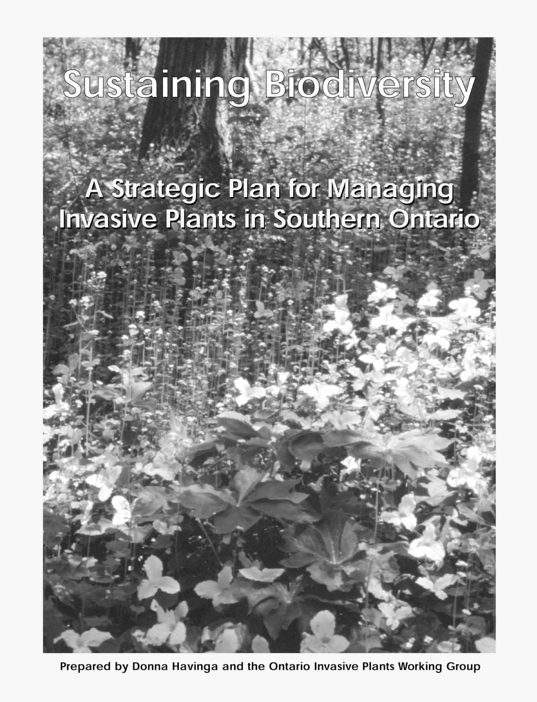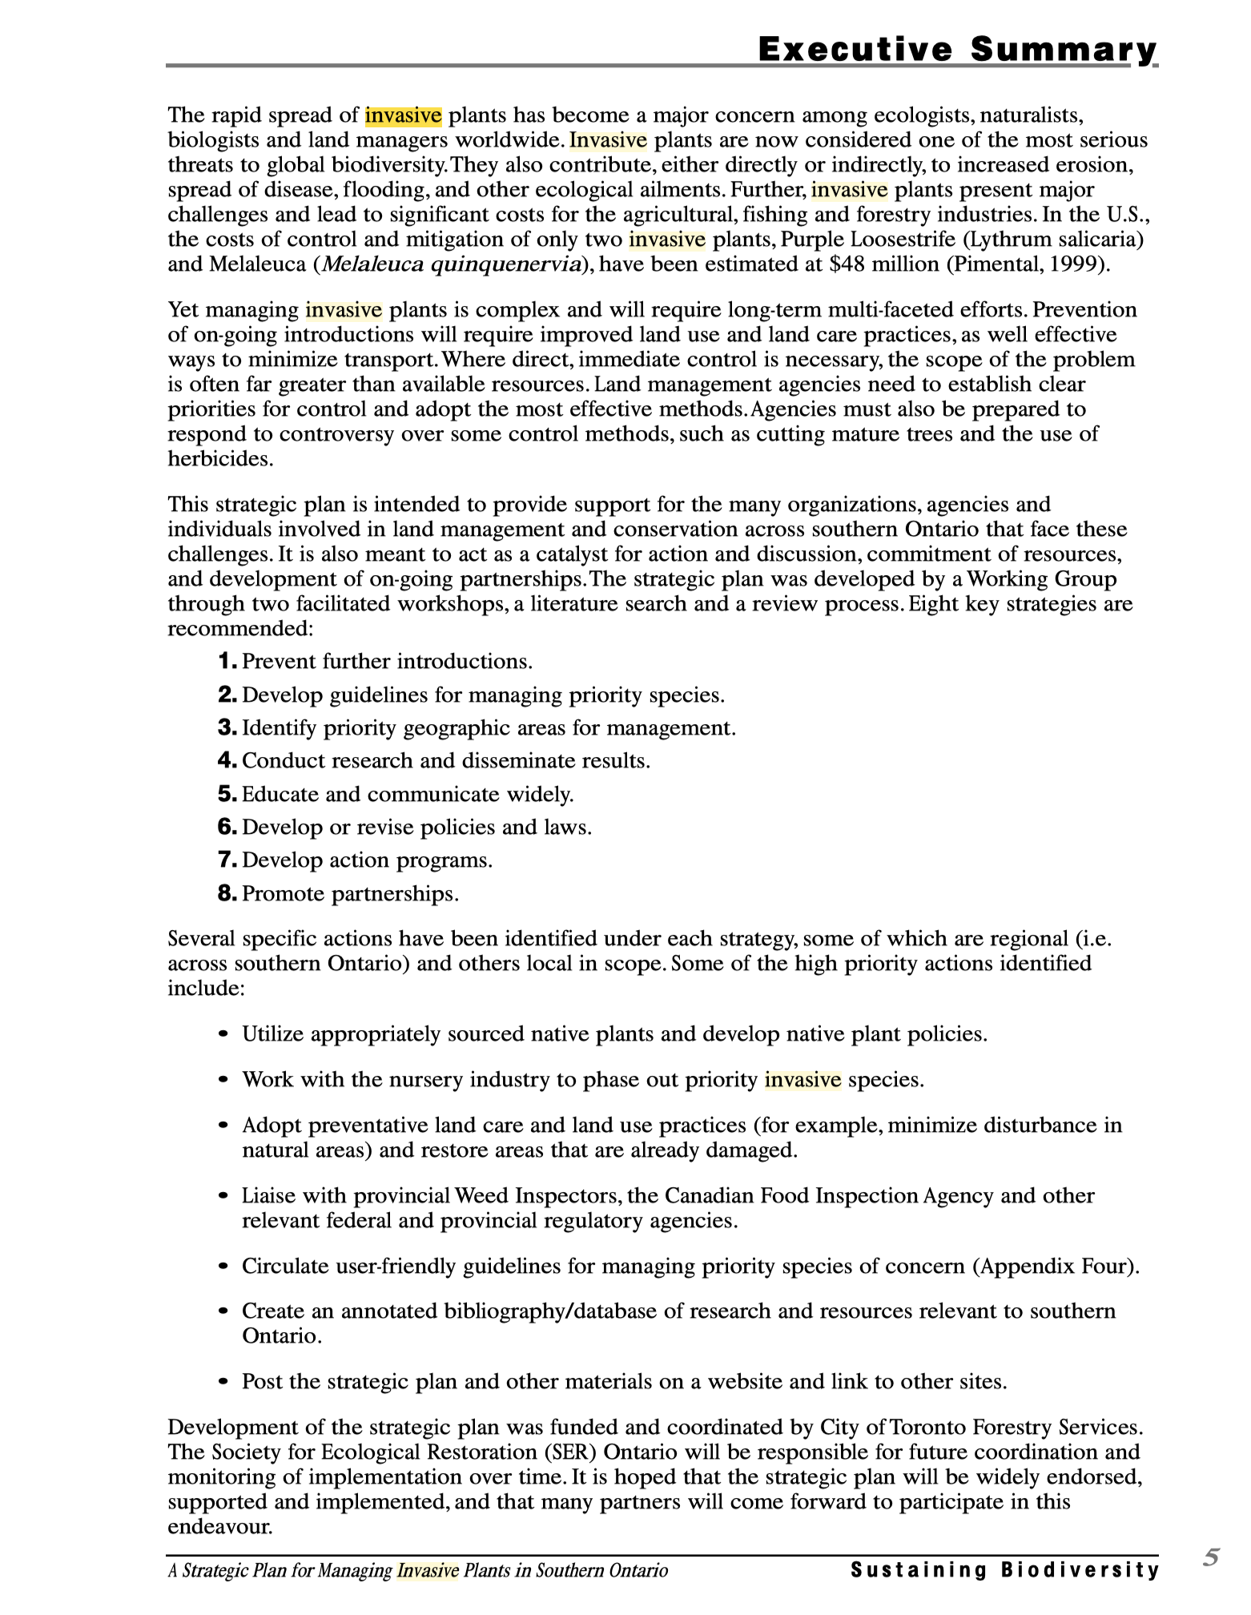

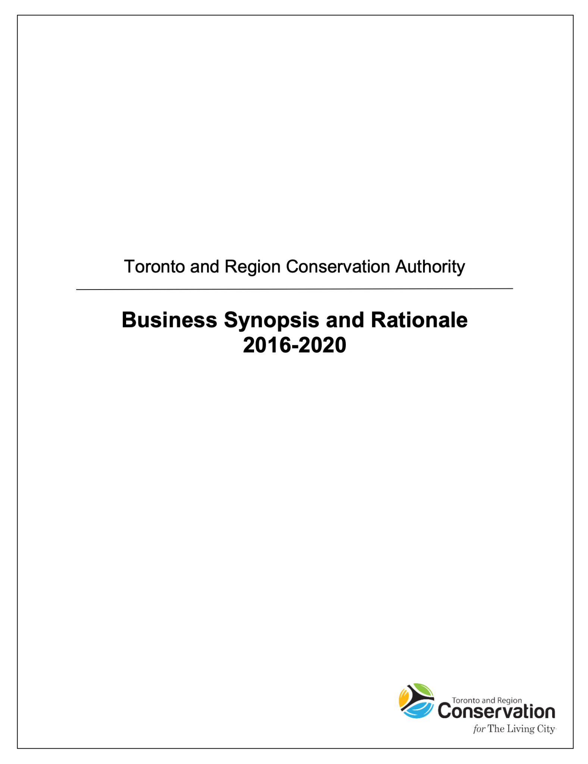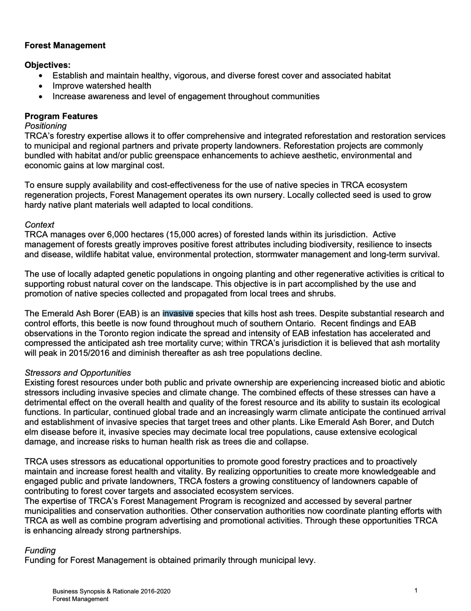

Figure S1. Examples of how invasive species are discussed in policy documents. In each row, the left panel shows the title page, and the right shows invasive species discussion.

# Table S1 – Cosine Similarities for Alewife

|  |  |  |  |  |  |
| --- | --- | --- | --- | --- | --- |
| Table S1. Example of word embedding results per n-gram for alewife, a non-native species in Ontario (using standardized cosine similarity). The composite measure of semantic distance used in the paper was taken by taking an average of the final column (mean_sim) across n-grams included in the composite semantic distance measure. There were an additional 16 simulations of the model (Simulations 3-19) used to compute the Mean_Sim column which are omitted here as this example is intended to demonstrate how embedding values were computed. Numbers included in the table are also more precise, but 3 numbers after the decimal are reported for presentation purposes. These are absolute cosine similarity values before standardization. | | | | | |
| **Species Name** | **N-gram** | **Sim 1** | **Sim 2 …** | **Sim 20** | **Mean_Sim** |
| alewife | invasive_non-native | 0.555 | 0.556 | 0.570 | 0.567 |
| alewife | invasive_round_goby | 0.644 | 0.493 | 0.461 | 0.566 |
| alewife | highly_invasive | 0.573 | 0.564 | 0.528 | 0.555 |
| alewife | non-native_invasive_species | 0.500 | 0.492 | 0.579 | 0.551 |
| alewife | invasive_invertebrate | 0.530 | 0.543 | 0.529 | 0.545 |
| alewife | non-native_invasive | 0.543 | 0.529 | 0.602 | 0.543 |
| alewife | invasive_mussels | 0.511 | 0.505 | 0.536 | 0.538 |
| alewife | aquatic_invasive_species | 0.513 | 0.516 | 0.531 | 0.535 |
| alewife | invasive_native | 0.560 | 0.528 | 0.553 | 0.534 |
| alewife | invasive | 0.551 | 0.524 | 0.530 | 0.533 |
| alewife | invasives | 0.506 | 0.568 | 0.536 | 0.528 |
| alewife | invasives_such_as | 0.516 | 0.509 | 0.514 | 0.523 |
| alewife | become_invasive | 0.482 | 0.526 | 0.506 | 0.506 |
| alewife | invasive_exotics | 0.500 | 0.490 | 0.508 | 0.502 |
| alewife | pest_origins_invasive | 0.519 | 0.530 | 0.518 | 0.495 |
| alewife | invasive_exotic_plants | 0.493 | 0.506 | 0.478 | 0.490 |
| alewife | invasiveness | 0.503 | 0.489 | 0.522 | 0.490 |
| alewife | invasive_non-native_species | 0.473 | 0.503 | 0.491 | 0.482 |
| alewife | invasive_pests | 0.481 | 0.463 | 0.460 | 0.481 |
| alewife | invasive_aliens | 0.496 | 0.466 | 0.472 | 0.480 |
| alewife | invasive_alien_plant | 0.506 | 0.463 | 0.485 | 0.470 |
| alewife | alien_invasive_species | 0.484 | 0.482 | 0.478 | 0.469 |
| alewife | invasiveness_score | 0.479 | 0.492 | 0.494 | 0.469 |
| alewife | invasive_alien_species | 0.459 | 0.456 | 0.452 | 0.468 |
| alewife | invasive_plant_indicators | 0.483 | 0.490 | 0.508 | 0.468 |
| alewife | non-invasive | 0.409 | 0.458 | 0.453 | 0.467 |
| alewife | invasive_exotic_species | 0.482 | 0.453 | 0.447 | 0.467 |
| alewife | invasive_species | 0.458 | 0.466 | 0.464 | 0.461 |
| alewife | invasive_insect | 0.493 | 0.432 | 0.490 | 0.461 |
| alewife | invasive_shrubs | 0.491 | 0.471 | 0.423 | 0.458 |
| alewife | invasive_plants | 0.459 | 0.446 | 0.467 | 0.455 |
| alewife | exotic_invasive | 0.423 | 0.383 | 0.489 | 0.453 |
| alewife | invasive_common_reed | 0.528 | 0.453 | 0.470 | 0.453 |
| alewife | non-native_invasive_plants | 0.495 | 0.375 | 0.435 | 0.453 |
| alewife | managing_invasive_species | 0.422 | 0.433 | 0.431 | 0.447 |
| alewife | invasiveness_scores | 0.515 | 0.474 | 0.478 | 0.447 |
| alewife | invasive_indicator | 0.450 | 0.432 | 0.471 | 0.446 |
| alewife | compete_with_invasives | 0.505 | 0.443 | NA | 0.445 |
| alewife | invasive_alien_plants | 0.464 | 0.443 | 0.492 | 0.444 |
| alewife | live_invasive | 0.463 | 0.427 | 0.538 | 0.440 |
| alewife | aquatic_invasive_spcdcs | 0.425 | 0.472 | 0.531 | 0.438 |
| alewife | invasive_plant_species | 0.448 | 0.437 | 0.426 | 0.438 |
| alewife | invasive_species_introductions | 0.431 | 0.467 | 0.487 | 0.438 |
| alewife | invasive_non-native_plants | 0.504 | NA | 0.462 | 0.437 |
| alewife | invasive_indicators | 0.438 | 0.451 | 0.481 | 0.431 |
| alewife | restricted_invasive_species | 0.415 | 0.439 | 0.465 | 0.430 |
| alewife | prohibited_invasive_species | 0.416 | 0.456 | NA | 0.427 |
| alewife | control_invasive_species | 0.410 | 0.401 | 0.433 | 0.426 |
| alewife | invasive_flora_species | 0.354 | 0.450 | 0.366 | 0.422 |
| alewife | invasive_plant_populations | 0.404 | 0.428 | 0.434 | 0.420 |
| alewife | several_invasive_plant | 0.396 | 0.423 | 0.437 | 0.416 |
| alewife | invasive_species_prevention | 0.365 | 0.378 | 0.412 | 0.414 |
| alewife | managing_invasive_plants | 0.450 | 0.370 | 0.425 | 0.414 |
| alewife | invasive_plant_council | 0.408 | 0.393 | 0.416 | 0.413 |
| alewife | invasive_pest | 0.395 | 0.405 | 0.407 | 0.411 |
| alewife | suspected_invasive_species | 0.412 | 0.497 | 0.411 | 0.408 |
| alewife | invasive_exotic_plant | 0.420 | 0.401 | 0.412 | 0.400 |
| alewife | invasive_exotic | 0.384 | 0.405 | 0.375 | 0.398 |
| alewife | native_non-invasive | 0.422 | 0.423 | 0.364 | 0.395 |
| alewife | alien_invasive_plant | 0.415 | 0.430 | 0.474 | 0.395 |
| alewife | exotic_invasive_species | 0.373 | 0.376 | 0.376 | 0.389 |
| alewife | invasive_plant | 0.414 | 0.357 | 0.361 | 0.383 |
| alewife | live_invasive_carps | 0.452 | 0.477 | 0.465 | 0.378 |
| alewife | invasive_species_removal | 0.372 | 0.375 | 0.374 | 0.377 |
| alewife | prevent_further_invasive_species | 0.410 | 0.374 | 0.417 | 0.376 |
| alewife | invasive_plants_working_group | 0.406 | 0.332 | 0.385 | 0.372 |
| alewife | controlling_invasive_species | 0.297 | 0.300 | 0.363 | 0.361 |
| alewife | invasive_alien_vine_vincetoxicum | 0.401 | NA | 0.355 | 0.334 |
| alewife | invasive_species_control | 0.312 | 0.301 | 0.298 | 0.326 |
| alewife | eradicate_invasive_species | 0.432 | 0.457 | NA | 0.314 |
| alewife | determine_if_non-native_invasive | 0.475 | 0.443 | NA | 0.303 |
| alewife | pest_index_invasive | 0.413 | NA | 0.433 | 0.188 |
| alewife | managing_invasive | 0.299 | NA | NA | 0.169 |
| alewife | invasive_alien | 0.418 | NA | 0.394 | 0.140 |
| alewife | removing_invasive_species | 0.489 | NA | NA | 0.017 |

# Table S2 – Generating the Dependent Variable

|  |  |  |  |  |  |  |
| --- | --- | --- | --- | --- | --- | --- |
| Table S2. N-grams included in the six dependent variables evaluated in this study. | | | | | | |
| **n-gram** | **Var1** | **Var2** | **Var3** | **Var4** | **Var5** | **Var6** |
| alien_invasive_species | 1 | 1 | 1 | 1 | 1 | 1 |
| become_invasive | 1 | 1 | 1 | 1 | 1 | 1 |
| exotic_invasive | 1 | 1 | 1 | 1 | 1 | 1 |
| exotic_invasive_species | 1 | 1 | 1 | 1 | 1 | 1 |
| highly_invasive | 1 | 1 | 1 | 1 | 1 | 1 |
| invasive | 1 | 1 | 1 | 1 | 1 | 1 |
| invasive_alien_species | 1 | 1 | 1 | 1 | 1 | 1 |
| invasive_aliens | 1 | 1 | 1 | 1 | 1 | 1 |
| invasive_exotic | 1 | 1 | 1 | 1 | 1 | 1 |
| invasive_exotic_species | 1 | 1 | 1 | 1 | 1 | 1 |
| invasive_exotics | 1 | 1 | 1 | 1 | 1 | 1 |
| invasive_non-native | 1 | 1 | 1 | 1 | 1 | 1 |
| invasive_non-native_species | 1 | 1 | 1 | 1 | 1 | 1 |
| invasive_species | 1 | 1 | 1 | 1 | 1 | 1 |
| invasiveness | 1 | 1 | 1 | 1 | 1 | 1 |
| invasives | 1 | 1 | 1 | 1 | 1 | 1 |
| invasives_such_as | 1 | 1 | 1 | 1 | 1 | 1 |
| non-native_invasive | 1 | 1 | 1 | 1 | 1 | 1 |
| non-native_invasive_species | 1 | 1 | 1 | 1 | 1 | 1 |
| live_invasive | 0 | 0 | 0 | 0 | 0 | 1 |
| invasive_alien_plants | 0 | 0 | 0 | 0 | 0 | 1 |
| invasive_pest | 0 | 0 | 0 | 0 | 0 | 1 |
| invasive_pests | 0 | 0 | 0 | 0 | 0 | 1 |
| pest_index_invasive | 0 | 0 | 0 | 0 | 0 | 1 |
| pest_origins_invasive | 0 | 0 | 0 | 0 | 0 | 1 |
| alien_invasive_plant | 0 | 0 | 0 | 0 | 0 | 1 |
| aquatic_invasive_spcdcs | 0 | 0 | 0 | 0 | 0 | 1 |
| aquatic_invasive_species | 0 | 0 | 0 | 0 | 0 | 1 |
| invasive_alien_plant | 0 | 0 | 0 | 0 | 0 | 1 |
| invasive_alien_vine_vincetoxicum | 0 | 0 | 0 | 0 | 0 | 1 |
| invasive_common_reed | 0 | 0 | 0 | 0 | 0 | 1 |
| invasive_exotic_plant | 0 | 0 | 0 | 0 | 0 | 1 |
| invasive_exotic_plants | 0 | 0 | 0 | 0 | 0 | 1 |
| invasive_flora_species | 0 | 0 | 0 | 0 | 0 | 1 |
| invasive_insect | 0 | 0 | 0 | 0 | 0 | 1 |
| invasive_invertebrate | 0 | 0 | 0 | 0 | 0 | 1 |
| invasive_mussels | 0 | 0 | 0 | 0 | 0 | 1 |
| invasive_non-native_plants | 0 | 0 | 0 | 0 | 0 | 1 |
| invasive_plant | 0 | 0 | 0 | 0 | 0 | 1 |
| invasive_plant_council | 0 | 0 | 0 | 0 | 0 | 1 |
| invasive_plant_indicators | 0 | 0 | 0 | 0 | 0 | 1 |
| invasive_plant_populations | 0 | 0 | 0 | 0 | 0 | 1 |
| invasive_plant_species | 0 | 0 | 0 | 0 | 0 | 1 |
| invasive_plants | 0 | 0 | 0 | 0 | 0 | 1 |
| invasive_plants_working_group | 0 | 0 | 0 | 0 | 0 | 1 |
| invasive_round_goby | 0 | 0 | 0 | 0 | 0 | 1 |
| invasive_shrubs | 0 | 0 | 0 | 0 | 0 | 1 |
| live_invasive_carps | 0 | 0 | 0 | 0 | 0 | 1 |
| managing_invasive_plants | 0 | 0 | 0 | 0 | 0 | 1 |
| non-native_invasive_plants | 0 | 0 | 0 | 0 | 0 | 1 |
| several_invasive_plant | 0 | 0 | 0 | 0 | 0 | 1 |
| eradicate_invasive_species | 0 | 0 | 0 | 0 | 1 | 1 |
| invasive_species_prevention | 0 | 0 | 0 | 0 | 1 | 1 |
| prevent_further_invasive_species | 0 | 0 | 0 | 0 | 1 | 1 |
| managing_invasive | 0 | 1 | 0 | 1 | 1 | 1 |
| managing_invasive_species | 0 | 1 | 0 | 1 | 1 | 1 |
| control_invasive_species | 0 | 1 | 0 | 1 | 1 | 1 |
| controlling_invasive_species | 0 | 1 | 0 | 1 | 1 | 1 |
| invasive_species_control | 0 | 1 | 0 | 1 | 1 | 1 |
| invasive_species_removal | 0 | 1 | 0 | 1 | 1 | 1 |
| removing_invasive_species | 0 | 1 | 0 | 1 | 1 | 1 |
| invasive_indicator | 0 | 0 | 0 | 0 | 1 | 1 |
| invasive_indicators | 0 | 0 | 0 | 0 | 1 | 1 |
| invasiveness_score | 0 | 0 | 0 | 0 | 1 | 1 |
| invasiveness_scores | 0 | 0 | 0 | 0 | 1 | 1 |
| prohibited_invasive_species | 0 | 0 | 1 | 1 | 1 | 1 |
| restricted_invasive_species | 0 | 0 | 1 | 1 | 1 | 1 |
|  |  |  |  |  |  |  |
| *Note*: In the analyses reported in the main body of the paper, only dependent variable 1 was used. In line with our expectations, it more clearly related to the independent variables in the study, as it is the most focused estimate of invasive meaning. | | | | | | |

# Figure S2 – Monitoring Document Example

# Figure S3 – Merging Procedure



Figure S3. Steps for constructing the merged data set used in Table 2 in the main text.

# Sources of Texts

First, the TRCA has a public database of internal and external policy documents (TRCA 2023), of which 292 included instances of “invasive.” Second, this first set referenced 45 additional documents that were central to a given policy, such as invasive species lists created by the provincial government, laws, journal articles by staff, or news articles by TRCA members. Third, we collected 262 documents published by the TRCA on their website, such as watershed management plans and biodiversity strategies. Across the three sources, documents ranged from a few paragraphs (e.g., some of the shorter meeting minutes) to hundreds of pages (e.g., long term management plans and ecological assessments). There were two documents published before 1990, 19 from 1990-1999, 210 from 2000-2009, 363 from 2010-2019, and 5 from 2020. The collection period ended at the start of 2020, accounting for the relatively few documents collected for that year.

# Decision Trees

The decision trees for constructing the categorical species-level variables were a single path decision tree and we referred to them, as a result, as decision pipelines. The decision pipelines are provided below for each variable. Species were classified into these categories based on a review of 392 documents that discuss the species’ ecological effects and a review of information datasheets provided by organizations such as the Centre for Agriculture and Bioscience International’s Invasive Species Compendium and Canada’s Invasive Species Centre. Organizations such as the Centre for Agriculture and Bioscience International (CABI) provided general information on how each species interacts with a wide array of global environments, and organizations such as the Invasive Species Centre provided more localized information pertinent to the TRCA’s jurisdiction.

We created the pipelines to involve clear cut-offs between the different categories. For example, for ecological impact, the “low” category included species for which there was little or no mention of ecological impacts in any of the supporting documents. The “moderate” category included species for which some impacts were described, but the species was not listed as a global species of concern in databases such as CABI’s, did not appear on major inventories of ecologically harmful species such as on the Invasive Species Centre’s information datasheets, and in the academic and management literature collected for the species, the species was not described as a wide-scale ecological threat. The “high” category included species widely listed as major ecological threats in the organizations’ information factsheets and/or was described by the academic and management literature as having wide-scale damaging effects to local ecosystems, with higher weight given to studies and management literature pertaining to the TRCA’s jurisdiction and Ontario.

## Ecological Impact

*The pipeline starts at this attribute.*

**Low**

*The species does not cross the low-medium threshold if it is considered native in part of the TRCA jurisdiction or if it is non-native yet provides significant habitat, ecosystem services, and/or functions that maintain biodiversity and ecosystem health. Government and arms-length government organizations that make online databases with information about invasive species do not describe the species as having major ecological impacts. For some non-native species, there may just not be much information. But the lack of information partly indicates that the impacts are not as great as for other non-native species, as these impacts have not been extensive enough to be perceived. Typical organizations that track invasive species (Ontario Invasive Species Awareness Program, Ontario Invasive Plant Council [for plants], the Ontario Invasive Species Act restricted and prohibited species, CABI [cabi.org], Invasive Species Centre) will typically not list the species nor describe any common deleterious impacts. When listed by any of the primary organizations that track ecological impact, the organization discusses only minor impacts, such as on a small set of other organisms, rather than ecosystem wide changes. Some small herbaceous plants, for example, may remain at the low ecological impact level when they do not significantly change understory nor overstory composition, failing to inhibit the growth of native tree seedlings, not releasing chemicals into the soil that prevent germination or growth of native species, and not having a major impact on soil organisms nor small forest floor organisms.*

*The species crosses the low-medium threshold when it is understood to have some deleterious impacts. It is likely listed in at least one of the typical sources where invasive species are discussed in government and arms-length government invasive species lists.*

**Medium/Moderate**

*The species does not cross the medium-high threshold if it does not have extensive deleterious effects. Carrying forward the example from the previous section, a small herbaceous plant may have some effects on the forest floor, replacing native herbaceous plants, and affecting the soil ecosystem in various ways. But they may not lead to major changes across forest microhabitats. So species that are at the medium or moderate designation do have effects on parts of ecosystems but they are not typically so extensive as to cause major change across all microhabitats, and do not create ecosystem-wide changes such as preventing forest regeneration. An herbaceous plant species may cross the medium/moderate threshold into high, for example, if it releases allelopathic chemicals that greatly alter soil chemistry or if the species creates such a blanket on the forest floor that trees cannot regenerate through the layer created by it. That is, species cross the medium-high threshold when they affect many parts of ecosystems.*

*Species with the “high” designation for ecological impact affect many parts of ecosystems. It would be strange if they were not listed in at least some of the typical lists produced by institutions that track the ecological impacts of invasive species—if they are not listed in any of them, the species is probably not showing a “high” ecological impact, but is clearly listed for reasons other than ecological concerns. The species affects many parts of ecosystems.*

**High**

## Economic Costs to Industry

*The pipeline starts at this attribute.*

**Low**

*The species does not cross the low-medium boundary if there are no cited costs to industry in any of the sources that we were able to find. These sources include the widely circulated databases and lists of species costs, such as InvaCost. For example, small herbaceous species typically do have some impacts on other herbaceous species on the forest floor, and for soil micro-organism and arthropod communities, yet they do not typically have an observable cost for forestry. There are some vines like English ivy that can create such a thick blanket on the forest floor that they do have an observable effect on tree seedling establishment and would move on to the next level of this pipeline, but many herbaceous non-native species do not have that kind of an effect and no costs to industry are cited in source documents. A fish with a low cost to industry would often be considered naturalized and not be clearly negatively affecting any of the angling or commercial fishing operations in a jurisdiction. Sea lamprey, as a species that does create costs to the fishing industry, would move down the pipeline. If a species does have at least some demonstrable costs to industry, it moves into the “medium/moderate” attribute.*

**Medium/Moderate**

*A species remains at “medium/moderate” and does not move into “high” if there are some costs to industry discussed, but they are not extensive or affect only a small number of people. The species moves into the “high” attribute if there are extensive costs to industry, so much so that governments, land managers, farmers/ranchers, and others clearly act to control the species because of its economic costs to private interests.*

*At the high attribute, many documents will report the costs of the non-native species, and this will yield at least some estimates of the costs to industry incurred as a result of the species’ incursions. Asian long-horned beetle is an example of a species at this level: the species would devastate the maple sugar industry and forestry and is therefore given a high cost to industry.*

**High**

## Profitability (1/0)

**Not profitable**

*The species does not move into the profitable attribute if there are no mentions of profitability in source documents.*

*The species is considered profitable if, at least in some source documents, current economic industries do benefit from the species. Examples include the pet trade, horticultural sales, ivy infrastructure (e.g., businesses that build the supports for ivy on buildings), and governments who pay to establish the species (e.g., Kentucky bluegrass).*

**Profitable**

# Supplementary Data: Alternative Biological Abundance Variable

As a robustness check, we also downloaded all data published under an open license for the 75 focal species from the Global Biodiversity Information Facility. This included the Royal Ontario Museum data uploaded to the Global Biodiversity Information Facility database, but also public records such as those uploaded to that database from iNaturalist and from a small range of additional organizations. This data set included 1,576,461 records for the 75 focal species in Ontario. As with the first abundance proxy measure, the species list was used to clean this data. Since the first abundance metric uses TRCA monitoring records that complement Ontario-wide records, it is a more appropriate abundance metric, but this second abundance metric was still used to check whether the relative abundances – particularly in terms of the outliers – found in the first abundance metric repeat across a larger data set.

Therefore, the main objective with the supplementary abundance variable was to assess whether the outliers seen in the data used in the main body of the paper were repeated in a supplementary data set. In the second abundance metric we observed a similar relative frequency of the two outliers, namely *Passer domesticus* and *Sturnus vulgaris* (Figure S4). The difference we found in this larger dataset was that *S. vulgaris* had a higher relative abundance than *P. domesticus*. In this supplementary abundance variable, *P. domesticus* had over500,000 records and *S. vulgaris* had over 725,000 (Figure S4). Since the embedding values did not change between the models using the two different abundance variables, *S. vulgaris* had both a higher abundance and higher embedding value than *P. domesticus* in this supplementary abundance variable. While at first glance this might seem to contradict our claim that greater abundance is associated with lower invasive meaning at hyperabundant levels, these birds are still associated with median cosine similarity values and the divergent scale between the second abundance metric and the text needs to be taken into consideration. That is, the data used in our models is centered around the Toronto and Region Conservation Authority’s jurisdiction, which is largely urban, but the second abundance metric covers all of Ontario. *S. vulgaris* is known for expanding into enormous flocks in agricultural areas, and while *P. domesticus* is also found in agricultural areas, the size of the *S. vulgaris* flocks are often larger (Klug et al. 2023; Somers and Morris 2002).

# Supplementary Analysis: Qualitative Evidence for Workability

## Aquatic Animals in Comparison to Plant Biocontrol

We examined the policy documents to evaluate how the TRCA examines the variables we use to conceptualize workability. We coded the individual policies until we had a clear set of themes, and coded 25 documents at a time until we reached these themes, leading to a sample of the first 75 policies. We supplement this analysis by also examining how the TRCA describes species that have high, median, and low cosine similarity.

First, we found that aquatic animals and plant biocontrol was a revealing comparison. In describing aquatic species, Policy 25 in our database states,

Invasive species have become a serious issue in the Great Lakes area. The Ministry of Natural Resources has been working with anglers and hunters to increase the *awareness* of invasive species such as *zebra mussels, gobies and spiny water fleas*. *The lack of funding* has proven to be an obstacle. The Toronto area can be seen as a locus for information on this issue, since much of the population travels north on weekends and vacations. (Emphasis added).

Here the TRCA mentions that a primary strategy for dealing with three highly invasive aquatic animal species is to educate the public, which usually involves educating about the importance of cleaning boats when recreational boat users move between different water bodies. The intention of this education about boat cleaning is to avoid boat users transporting aquatic species from one water body to another (e.g., Bleitz, Walters, and Latimore 2024; OISAP 2025). The extreme difficulty of managing aquatic animal species (e.g., Astorg et al. 2022; Jansen, Gill, and Hann 2017; Johnson, Bunnell, and Knight 2005; Karatayev, Burlakova, and Padilla 2015; Sandiford 2015), therefore, leads the TRCA to recommend a prevention strategy over an eradication strategy.

They also note that even an educational strategy aimed at prevention is one that they do not have adequate funding for, suggesting an overall severe resource deficit when it comes to managing non-native species. Here, they specifically describe this resource deficit for the aquatic animal species they are hoping to develop this awareness program for – spiny water flea, goby[1] and zebra mussels.

In this same policy, the TRCA describes a control program for an invasive plant species: “A release program for the beetle that will control purple loose strife populations is being implemented throughout the province. The Toronto Region will be included in the 2005 program, ensuring that each watershed has been inoculated with the beetle.”

This paragraph describes that a highly cost-effective invasive species management method – the release of a biological animal control for a non-native plant – will be widely applied. A biological control is a species from an invasive species’ (such as purple loosestrife’s) native range that typically eats and decimates the invasive species’ population and which has been cleared for release in the region where the invasive species is causing deleterious impacts (e.g., Barratt et al. 2018). For example, the black-margined loosestrife beetle, which is native to Europe and Asia, has been widely released in Ontario to control purple loosestrife, also native to Europe and Asia (Warne 2016). Approving a potential biological control is a strenuous process, since ecosystem managers do not want to simply release a new invasive species, nor a species that decimates any locally native species, and thus they must first establish that the biocontrol species (such as the loosestrife beetle) is of minimal risk to the local ecosystem (MacKenzie 2023). Once it is cleared, the biological control becomes a highly cost-effective way to control a species, as the animal species – in this case a beetle – does the work of control and self-perpetuates.

Thus with these two passages from one policy, we can see workability operating with both land-based sessile species and aquatic animal species, demonstrating that relatively cost-effective and feasible solutions, such as educational campaigns and biological controls, are preferred. We found similar passages in other policies, such as in Policy 70, where the recommended action for controlling an aquatic mobile species, the rusty crayfish, is banning its sale, rather than controlling populations in water bodies. Specifically, the policy states, “[T]he Chair of the Humber Watershed Alliance [will] write a second letter to the Ministry of Natural Resources reiterating the Alliance’s position regarding *the ban of the rusty crayfish for sale or use as bait* and requesting a response to the first letter sent regarding this issue” (emphasis added). A ban on sales is a relatively workable solution for a species that is extremely difficult to locate and control in its aquatic habitat, such as the rusty crayfish (e.g., Ogle and Kret 2008).

## Community Events and Herbicides are Workable Solutions for Invasive Plants

Another theme in the documents is a type of event typically described as a “pull” or “removal” of non-native plant species. This demonstrates how land-based and sessile species are more workable. For example, some documents list upcoming events that the TRCA is attempting to organize and gain greater participation for, such as:

Malton Garlic Mustard Pull and Planting Event. Saturday May 8th, 2010 1p.m. - 4 p.m. @ Wildwood Park (3430 Derry Road East, Malton). Come learn about the impact of invasive plants. Help keep Wildwood beautiful and invasive free by removing garlic mustard and planting native wildflowers. (Policy 32)

June 18. Invasive Species Removal Day Boyd Conservation Area. Removal of garlic mustard and buckthorn. For additional information, contact [name of staff member], TRCA. (Policy 55)

Prepare a communications plan to raise awareness and inform surrounding communities … Monitor the trail for invasive plant material and prevent spread by using barriers etc. Monitor the presence of noxious weeds on site and remove in accordance with local noxious weed bylaws. Organize volunteers to pick invasive exotic plant species such as garlic mustard, buckthorn, dog strangling vine and purple loosestrife. (Policy 74)

Such plant removal events are only possible with sessile species, since they are predictable to find and easy to kill. In the third passage above, the TRCA division writing this policy says they will monitor a particular trail, which is relatively feasible as it requires simply walking down a trail, in comparison with monitoring, for example, the animals in a pond or a stream. Monitoring land-based sessile species, therefore, is highly workable. The land-based plants are, in addition, so easy to locate and kill that the typical volunteer can do it, for a variety of invasive plants. Ease of killing the species, therefore, is also an aspect of workability in this case.

In another document, the TRCA describes the self-efficacy benefits associated with controlling invasive plants, stating,

Members of the Sherway Trail team noticed a significant reduction of the invasive mustard plant at the annual mustard pull event. They see the plants and shrubs planted last year surviving, *which is exciting as their hard work is paying off.* (Policy 35)

This demonstrates that members of the public who participate in government-run control campaigns can also easily witness the effects of their control efforts on sessile land-based species, which can yield encouragement and thus continued effort. Workable problems are those that are more feasible to manage, and part of that greater feasibility is likely the motivation to keep controlling the problem. This kind of encouragement is critical in community motivation, since this motivation can be enhanced by seeing small wins and progress being made, which contributes to the success of community initiatives (e.g., Bleh et al. 2025; Correll 2017; Rao et al. 2024; Termeer and Dewulf 2019).

In addition, terrestrial herbicide application was periodically discussed in the policy documents as a feasible method to control land-based sessile species. Herbicide application is particularly effective in terrestrial ecosystems, compared to the many unpredictable effects that herbicides may have in aquatic ecosystems (e.g., Evans, Wilkie, and Burkhardt 2008). Herbicide application may, in other words, be more *workable* in a land-based setting, suggested by the fact that we only see a discussion of land-based herbicides in the policy documents. For example, Policy 73, called Use of Pesticides on Authority-controlled Lands, states,

Historically, the Authority has used chemical controls on its publicly accessible lands, on a limited basis. For the most part, this has involved the application of Glysophate (Roundup) to control vegetation around trees and fenceposts and on paved areas, and to treat areas where the public is exposed to poison ivy. In addition, Glysophate has been used at Foster Woods to control thistle and other invasive plants around donation trees and more formally landscaped areas.

The policy continues, outlining the strategy for application of herbicides in land-based ecosystems, and how their use should be limited given ecosystem and social health concerns. Overall, one way that land-based sessile species are relatively workable is that herbicide, itself a feasible solution, can be applied to control them. Since herbicides are relevant particularly for land-based plants, the workability of land-based herbicide application could be part of why land-based plants are more workable in our quantitative findings.

## Emerald Ash Borer and Asian Long-horned Beetle

Two beetles – land-based yet highly mobile – were also a focus of some of the policies and led to major governance actions. These beetles were emerald ash borer, which feeds exclusively on ash trees, and Asian long-horned beetle, which feeds on a variety of hardwood trees, such as maple. These beetles are wood borers, meaning the larvae eat the living parts of the trees underneath the bark, and emerge through the bark as adults, subsequently flying to other trees (Herms and McCullough 2014; Pedlar et al. 2020). The policy texts discuss how invasion of these beetles led to the TRCA and associated partners felling thousands of trees in an attempt to eradicate the Asian long-horned beetle and various management actions aimed at flattening the curve of emerald ash borer invasion, despite the latter being impossible to eradicate.

In the policy text data, the cosine similarity between the Asian long-horned beetle and invasiveness is slightly above the median, and for the emerald ash borer it is slightly below the median (Median of 0.520, Asian long-horned beetle at 0.524 and emerald ash borer at 0.495). The difference between the beetles corresponds with workability: emerald ash borer became understood as a lost cause since it became highly abundant, with management actions focused on mitigating damage and public safety (e.g., around falling dead trees) rather than eradication, while Asian long-horned beetle was seemingly eradicated after one infestation was found in 2003 and another in 2013 (e.g., Government of Ontario 2025).

In the data, Policy 35 is titled, “Update on the Asian Long-Horned Beetle”. It describes that,

The Asian Longhorned beetle (ALHB), *Anoplophore glabripennis*, is an invasive quarantine insect native to Asia known to attack and kill healthy trees. This beetle has devastated tree canopies in parts of New York, Chicago and Seattle since the late 1990s. On September 8, 2003 the first confirmed infestation of the beetle attacking trees in Canada was in the Toronto area. It is believed that the insect arrived via wooden packing material (i.e. skids, crates, etc.) … The Canadian Food Inspection Agency (CFIA), TRCA, the City of Toronto, the City of Vaughan, and other partners ***are implementing an aggressive campaign to identify, control and eradicate ALHB***. TRCA has a roster of staff (between 10-12 people every day rotating weekly) that are dedicated to surveying and eradicating these pests. All material from infested and neighbouring host trees must be destroyed to eliminate the risk of ALHB spreading to uninfested trees. These trees will be destroyed by chipping and subsequent composting at a secure location determined by the CFIA. The CFIA has been contacting businesses and the public in the infected area and are actively trying to trace any wood (from damaged trees) that might have been moved out of the area. (Bold emphasis added).

This passage demonstrates the extensive resources dedicated to campaigns that seek to eradicate non-native species, here in the case of Asian long-horned beetle. These resources include policy plans, but also material resources aimed at eradicating the species.

In contrast, for emerald ash borer, the plans involved creating “management strategies,” “plans,” and other measures not aimed at eradication but rather at long-term control:

[This following is a] [r]ationale for the recommendation that staff assist municipalities in developing their strategies for addressing the current issue of emerald ash borer (EAB): The Ajax, Mississauga, Brampton and Caledon Urban Forest Technical Reports prepared by TRCA each proposed the development of invasive species strategies. The draft study reports undertaken in Markham, Vaughan, Richmond Hill and Pickering contain the same direction. The presence of EAB in particular has rapidly become a high priority issue requiring specific action. TRCA staff is discussing with municipal staff how to address the issue in different parts of our watersheds. It is important to have a ***comprehensive plan*** that addresses all ash trees, from those in larger rural woodlands to urban street trees. All ash trees provide benefits to our shared watersheds and communities; their location in the landscape (in headwaters, on streets, in schoolyards, etc.) simply determines the kind of benefits they provide for people. CAs and municipalities provide a complementary role in ash and EAB management. TRCA has a role to play in managing the problem on TRCA lands, in promoting stewardship on private lands, and in contributing supporting expertise and advice to municipalities as they develop and implement their own EAB strategies. (Bold emphasis added).

Here we still that the management actions involve a different approach than for Asian long-horned beetle, focused on plans that prepare for the loss of all ash trees in the TRAC jurisdiction. This led to a relative greater focus on Asian long-horned beetle relative to the emerald ash borer, which was a likely cause of the latter’s relatively lower cosine similarity with invasiveness.

The comparison of these two beetles shows that organizational capacities are associated with relative species abundance in determining the response to non-native species. Asian long-horned beetle, as its abundance was manageable, was a focus of eradication, while emerald ash borer, which became highly abundant in the study period, was less closely associated with invasive and the management actions took different forms aimed at long-term control.

One other feature is also salient with these beetles: in addressing them, management actions were not focused on the beetles themselves. Trying to manage the beetles directly, given that they are small and highly mobile, was never discussed. Rather, the control method was to address the sessile land-based organisms on which these species feed – a range of hardwood trees for Asian long-horned beetle and ash trees for emerald ash borer. When attempting to eradicate Asian long-horned beetle, tens of thousands of trees were felled, to reduce the habitat available and thus gain a chance to eradicate the species. Therefore, the issue of mobile organisms was transformed into an issue of sessile organisms. The way that the beetles were managed, therefore, also aligns with our workability hypothesis, and underlies how mobility is a measure of workability in this particular context.

## Examples of High, Medium, and Low Species

Finally, we demonstrate how species that are recorded in the embeddings as high, medium, and low are described in the TRCA policy documents.

Purple loosestrife is the species with the highest cosine similarity with invasiveness in our dependent variable. The following quotes demonstrate how the species is described as invasive.

“Organize volunteers to pick invasive exotic plant species such as garlic mustard, buckthorn, dog strangling vine and purple loosestrife” (P74).

“[Objective to] significantly reduce dog strangling vine, purple loosestrife, European buckthorn, and other invasives on the site” (P294).

“Explore the potential for harvesting invasive plants, such as paper out of Purple Loosestrife or wood products from Norway Maple (Acer platanoides).” (P296)

“[Plan to] address established invasives such as purple loosestrife with biocontrol” (P319)

“Invasive plant species that have spread through the watershed include purple loosestrife, European buckthorn, dog-strangling vine, garlic mustard and the common reed.” (P360)

“Controls on invasive plants such as Phragmites and purple loosestrife are being implemented in coastal wetlands” (P398)

These quotes demonstrate that purple loosestrife is commonly described as invasive.

In contrast, the median species for the main dependent variable is Eurasian water-milfoil. This species, while described as invasive in several policies, is described using more neutral language in others. For example, one policy states,

“Alien introductions into Canada are becoming more frequent and difficult to track as global trade and travel expand. Europe used to be the main area of origin of alien species. In recent years, more species have been arriving from Asia, some with telltale names like the Asian long-horned beetle, Japanese bamboo, and Eurasian water milfoil.” (Policy 159).

Here, the species is described using the more neutral “alien,” referring to species that are foreign but not necessarily harmful. In other instances, it is described as non-native, when listed among other species, such as when a policy describes,

“[the] prevalence of non-native plants, including reed (Phragmites australis), reed canary grass (Phalaris arundinacea), purple loosestrife (Lythrum salicaria), curly pondweed (Potamogeton crispus), Eurasian milfoil (Myriophyllum spicatum), and frog bit (Hydrocharis morsus-ranae).” (Policy 413).

Similarly, the species one above the median of cosine similarity with invasiveness is common lilac, which was more often described as “not native” or “exotic” than “invasive”. “Exotic” is a term used in the same sense as non-native or alien, referring to species that do not have a long-term historical association with a given place, such as in the following quotes where common lilac is discussed as part of forest communities that the TRCA was monitoring.

“Exotic Deciduous Thicket (CUT1-c) consisting of exotic shrubs particularly buckthorn, shrub honeysuckle (Lonicera x bella), and common lilac (Syringa vulgaris) totals an area of 1.7 ha. Semi-open or partially treed communities (i.e., woodland, savannah and treed hedgerow) accounted for 11.1 ha and are mostly associated with stream corridors.” (P413).

“These communities, classified as Fresh-Moist Poplar Deciduous Forest (FOD8-1), were generally observed in areas adjacent to past disturbance such as between plantations and along road allowances. Ground and lower layers were typically comprised of a thick mixture of woody vines, herbaceous plants and shrubs; many such as Dog-strangling vine (Cynanchum rossicum), buckthorn (Rhamnus carthartica) and common lilac (Syringa vulgaris) are exotic.” (P531).

Some of the species that are included in the neighbouring words of “exotic” in these passages do have above-median cosine similarity with invasive, such as dog-strangling vine, but across the entire set of policy documents, such above-median species are more closely associated with “invasive”. The question is not whether dog-strangling vine ever includes “exotic” as a neighbouring word, but whether, across the policy documents, it tends to more often include words in our composite invasiveness measure than do species with lower cosine similarity to invasive. Across the documents, invasiveness is more closely associated with dog-strangling vine than common lilac.

Brown trout is the species with the lowest cosine similarity to invasiveness in the data. For example, it is mentioned neutrally in association with a plan to restore a native species, Atlantic salmon:

“Restoration of Atlantic Salmon in Lake Ontario and key tributaries is a goal identified in the LAMP’s BBCS and Great Lakes Fishery Commission’s Lake Ontario Fish Community Objectives. In addition to Atlantic Salmon, Lake Ontario tributaries also provide spawning habitat to other migratory fish including Chinook Salmon, Coho Salmon, Rainbow Trout and Brown Trout. Monitoring migrating adult Atlantic Salmon is an important indicator of restoration progress but it is complicated by migration of large numbers of these other salmon and trout species that spawn at similar times.” (P424).

All of the species associated with the term “migratory” in this quote – which includes chinook salmon, coho salmon, rainbow trout, and brown trout – are non-native, yet they are not associated with invasiveness in this particular document.

Why these species are not closely associated with invasiveness may be better understood through examining another policy document, where some of these same species, including brown trout, are similarly not closely associated with invasiveness. Rather, brown trout is closely associated with the term “introduced,” another synonym of “non-native”, and the document reveals that the Ontario Ministry of Natural Resources (NMR) actively stocks several of the non-native fish species because they are popular in the sport fishing community.

“Other introduced species, such as chinook salmon and rainbow and brown trout, are commonly found throughout the lower reaches of the Duffins and Carruthers systems. These species are very popular in the angling community and are still stocked into Lake Ontario by the OMNR.”

These sport fish species were coded as “profitable” in our data, yet the profitable species overall were not sufficient to make the “profitable” variable significant. However, in the case of non-native sport fish, their economic role likely has an important influence on their deprioritization as “invasive” species in the TRCA’s policy documents.

In sum, the qualitative themes from the data demonstrate some of the organizational factors that are considered by the TRCA, and some of the ways that invasive species are interpreted in the documents themselves. These discussions highlight some means through which mobility, environment, and abundance affect workability in the non-native species context. Animals may be deprioritized due to their extreme elusiveness, such as with wood boring beetles and aquatic animals, while plants may be more tractable, given the management actions that may be performed to at least give a semblance of reducing their populations in given areas, such as volunteer “pull” events and applying herbicides. This data provides greater depth to inform our quantitative findings, demonstrating how the species that have relatively high or low cosine similarities with invasiveness are discussed in context.

# Validation of composite vector used in embedding analysis

The issue of n-gram instability is important to address, and our implementation mitigates it in several ways. First, the genism bi-gram identifying algorithm that we used automatically creates n-grams only out of frequently co-occurring ordered sets of words. The algorithm we use was created by Mikolov et al. (2013) along with the Word2Vec algorithm for the purpose of treating multi-word terms as single terms in embedding analyses to improve performance.

The frequency table below shows the frequency in our corpus of the 19 terms we used in creating the dependent measure. The least frequent term still occurs 12 times and the most frequent term is one of the n-grams. The n-gram terms account for ~79% of the occurrences of these invasive terms.

|  |  |
| --- | --- |
| Term | Frequency |
| invasive_species | 2275 |
| invasive | 657 |
| invasives | 103 |
| invasive_alien_species | 88 |
| invasive_exotic_species | 61 |
| invasiveness | 56 |
| invasive_non-native_species | 48 |
| non-native_invasive_species | 41 |
| invasive_non-native | 27 |
| invasives_such_as | 27 |
| exotic_invasive_species | 21 |
| invasive_exotics | 20 |
| non-native_invasive | 19 |
| invasive_exotic | 18 |
| become_invasive | 18 |
| highly_invasive | 17 |
| alien_invasive_species | 16 |
| invasive_aliens | 15 |
| exotic_invasive | 12 |

Second, Word2Vec’s min_count parameter (set to 5 in our implementation) excludes rare terms, ensuring vectors are only learned for n-grams with sufficient occurrences for reliable estimation.

To further validate using the n-grams, we compared how well a 3-term/single word resultant vector and our original 19-term/n-gram resultant vector locate the invasive concept in embedding space. The 3-term resultant vector averaged the vectors of the single words: invasive, invasives, and invasiveness. The original 19-term resultant vector was created as discussed in the main paper, by averaging the vectors of each of the terms included. We compared each of these resultant vectors against 106 invasion-related terms that we inductively identified as nearest neighbors of the single word “invasive” across our 20 bootstrapped embeddings. The table below shows that the 19-term resultant vector was closer to 74% of 106 validation terms (78 of 106), with a higher mean cosine similarity (0.511 vs 0.469) than the 3-term resultant vector. This indicates that the n-gram terms improve rather than add noise to the location of the invasive concept in embedding space.

|  |  |  |  |
| --- | --- | --- | --- |
| Term | Cosine Sim (3-term) | Cosine Sim (19-term) | Δ (19-term − 3-term) |
| vincetoxicum_spp | 0.387384 | 0.571405 | 0.184021 |
| predation_from | 0.434512 | 0.600556 | 0.166044 |
| herb_robert_geranium_robertianum | 0.52602 | 0.685404 | 0.159384 |
| out-compete_native_species | 0.535672 | 0.691515 | 0.155844 |
| weedy | 0.487966 | 0.639266 | 0.1513 |
| out_compete | 0.41904 | 0.560004 | 0.140964 |
| out-competing | 0.498048 | 0.637299 | 0.13925 |
| non-natives | 0.347391 | 0.486518 | 0.139128 |
| petiolata | 0.512195 | 0.651254 | 0.139059 |
| mugwort | 0.295442 | 0.433138 | 0.137696 |
| weeds | 0.491736 | 0.621819 | 0.130083 |
| exotic_plants | 0.437359 | 0.563005 | 0.125647 |
| planipennis | 0.519873 | 0.643913 | 0.12404 |
| outcompete_native | 0.420639 | 0.543797 | 0.123158 |
| crustaceans | 0.272384 | 0.388487 | 0.116102 |
| exotics_such_as | 0.524692 | 0.640667 | 0.115975 |
| highly_vulnerable | 0.241509 | 0.350099 | 0.10859 |
| weevil | 0.539445 | 0.636873 | 0.097428 |
| predatory | 0.399963 | 0.494677 | 0.094713 |
| diseases | 0.483326 | 0.572995 | 0.089669 |
| propagation | 0.356515 | 0.444057 | 0.087542 |
| competition | 0.492431 | 0.579142 | 0.086711 |
| exotic | 0.605966 | 0.689486 | 0.08352 |
| invasive_flora_species | 0.230626 | 0.312395 | 0.081769 |
| non_native | 0.438136 | 0.519888 | 0.081752 |
| woody | 0.445011 | 0.524358 | 0.079347 |
| herbaceous_species | 0.461895 | 0.540739 | 0.078844 |
| suppressed | 0.402353 | 0.477937 | 0.075585 |
| undesirable | 0.38847 | 0.463226 | 0.074755 |
| perennials | 0.341036 | 0.413805 | 0.072769 |
| woody_species | 0.47685 | 0.546113 | 0.069263 |
| mildly | 0.315617 | 0.384465 | 0.068849 |
| aggressively | 0.539936 | 0.607453 | 0.067517 |
| aggressive | 0.641847 | 0.709005 | 0.067159 |
| nonnative_species | 0.462442 | 0.528924 | 0.066483 |
| nonnative | 0.553647 | 0.620075 | 0.066428 |
| eastern_europe | 0.515223 | 0.580868 | 0.065646 |
| non-invasive | 0.389269 | 0.453953 | 0.064684 |
| resprouting | 0.467473 | 0.530817 | 0.063343 |
| rhizome | 0.421625 | 0.48313 | 0.061505 |
| alien_species | 0.472626 | 0.53406 | 0.061434 |
| nuisance | 0.478669 | 0.538633 | 0.059964 |
| have_become_established | 0.503597 | 0.562687 | 0.05909 |
| spreading | 0.46873 | 0.527431 | 0.058701 |
| exclosures | 0.333602 | 0.390585 | 0.056983 |
| seed_production | 0.518112 | 0.573104 | 0.054992 |
| non-native | 0.602074 | 0.655324 | 0.05325 |
| pests | 0.454551 | 0.50694 | 0.052389 |
| natives | 0.497838 | 0.549803 | 0.051965 |
| exotics | 0.456279 | 0.506847 | 0.050568 |
| flea | 0.406395 | 0.455764 | 0.049368 |
| swallow-wort | 0.580103 | 0.629154 | 0.04905 |
| implicated | 0.400285 | 0.448085 | 0.0478 |
| cool_season | 0.359141 | 0.406651 | 0.04751 |
| non-indigenous | 0.550689 | 0.5974 | 0.046711 |
| seed_bank | 0.538105 | 0.583256 | 0.045151 |
| replanting | 0.114909 | 0.1589 | 0.043991 |
| native_plant | 0.572794 | 0.61536 | 0.042566 |
| suppression | 0.40727 | 0.449368 | 0.042098 |
| become_established | 0.612031 | 0.650735 | 0.038704 |
| exotic_species | 0.564108 | 0.600154 | 0.036046 |
| crayfish | 0.509498 | 0.543493 | 0.033996 |
| pest | 0.442924 | 0.476661 | 0.033737 |
| devastating | 0.514292 | 0.54684 | 0.032548 |
| zebra_mussels | 0.474504 | 0.500609 | 0.026106 |
| high-priority | 0.424605 | 0.449077 | 0.024472 |
| fungus | 0.517337 | 0.541714 | 0.024377 |
| non-native_species | 0.590602 | 0.61479 | 0.024187 |
| impenetrable | 0.360883 | 0.37784 | 0.016957 |
| viral_hemorrhagic_septicemia_vhs | 0.524669 | 0.533889 | 0.00922 |
| vectors | 0.404001 | 0.415119 | 0.011118 |
| invasive_plants | 0.629629 | 0.638236 | 0.008607 |
| eradicating | 0.506849 | 0.515086 | 0.008237 |
| bythotrephes | 0.444402 | 0.452474 | 0.008072 |
| non-native_plants | 0.407969 | 0.413431 | 0.005462 |
| eradication | 0.431924 | 0.436957 | 0.005033 |
| aquatic_invasive_species | 0.385926 | 0.386971 | 0.001045 |
| invasive_plant_species | 0.50539 | 0.505597 | 0.000207 |
| introductions | 0.494805 | 0.492678 | -0.00213 |
| eradicate | 0.541217 | 0.538654 | -0.00256 |
| nis | 0.430321 | 0.420485 | -0.00984 |
| new_introductions | 0.538568 | 0.526936 | -0.01163 |
| invader | 0.500074 | 0.487117 | -0.01296 |
| zebra_mussel | 0.410349 | 0.393813 | -0.01654 |
| invaders | 0.647126 | 0.630582 | -0.01654 |
| invasions | 0.561454 | 0.54411 | -0.01734 |
| dominance | 0.501432 | 0.48349 | -0.01794 |
| spread | 0.552666 | 0.532499 | -0.02017 |
| control_methods | 0.522521 | 0.500416 | -0.0221 |
| dsv | 0.507524 | 0.485384 | -0.02214 |
| native | 0.366676 | 0.342097 | -0.02458 |
| zebra | 0.491446 | 0.466731 | -0.02471 |
| quagga_mussels | 0.46995 | 0.444039 | -0.02591 |
| trials | 0.357422 | 0.330197 | -0.02722 |
| biological_controls | 0.531213 | 0.503196 | -0.02802 |
| rapid_response | 0.453685 | 0.421068 | -0.03262 |
| ais | 0.429095 | 0.390996 | -0.0381 |
| introduced | 0.46311 | 0.424628 | -0.03848 |
| rusty_crayfish | 0.47072 | 0.430144 | -0.04058 |
| dreissenid_mussels | 0.504229 | 0.459301 | -0.04493 |
| biological_control | 0.617881 | 0.572197 | -0.04568 |
| invasive_plant | 0.513926 | 0.460224 | -0.0537 |
| early_detection | 0.463856 | 0.39832 | -0.06554 |
| colonization | 0.52745 | 0.459286 | -0.06816 |
| invasion | 0.56512 | 0.482822 | -0.0823 |
| alien | 0.567334 | 0.480006 | -0.08733 |

We did one additional validation test for the 19 terms. We examined whether the 19 terms function together as a coherent measure. To check this, we did a principal component analysis (PCA) on the 78 × 19 matrix of species-by-term cosine similarities. This shows the internal consistency of all 19 terms, i.e. whether the 19 terms covary in the same direction across species. This is completely independent of any relationship that the cosine similarities might have with predictor variables in the GAM.

The first principal component explained 73.5% of variance, with all 19 terms loading positively (range: 0.12–0.34). This indicates that the terms capture a single underlying dimension. The 19-term average correlated nearly perfectly with PC1 scores (r = 0.998), while the 3-term average captured less of this dimension (r = 0.878). PC1 represents a statistically optimal summary measure of how species’ cosine similarities vary across all 19 terms. The 19-term average is nearly a perfect proxy for this optimal summary (r = 0.998), which means that a simple average of all 19 cosine similarities captures the underlying construct with virtually no loss. The 3-term average correlates less strongly with PC1 (r = 0.878), indicating that it captures the same general dimension but with greater measurement error. This is analogous to how a combined 3-question survey scale could measure the same construct as a 19-question scale but with less precision. This further supports the conclusion that the compound terms strengthen the measurement of the invasive concept, rather than add noise.

This validation process supports using the 19 terms to locate the invasive concept in embedding space. Additionally, prior research has demonstrated that word embeddings capture semantic relationships more effectively than keyword-frequency approaches by representing meaning relationally rather than through discrete counts (Arseniev-Koehler 2022; Kozlowski, Taddy, and Evans 2019; Stoltz and Taylor 2021). Stoltz and Taylor (2021) note that “using the frequency of keywords is a classic approach in the formal analysis of text, but has the drawback of glossing over the relationality of word meanings,” and that embedding models overcome this by constructing a continuous meaning space where words are located based on similarity relations.

# References

Arseniev-Koehler, Alina. 2022. “Theoretical Foundations and Limits of Word Embeddings: What Types of Meaning Can They Capture?” *Sociological Methods & Research* 004912412211401. doi:10.1177/00491241221140142.

Astorg, Louis, Cristina Charette, Matthew J. S. Windle, and Alison M. Derry. 2022. “Two Decades since First Invasion: Revisiting Round Goby Impacts on Nearshore Aquatic Communities in the Upper St. Lawrence River.” *Journal of Great Lakes Research* 48(2):581–92. doi:10.1016/j.jglr.2022.01.017.

Barratt, B. I. P., V. C. Moran, F. Bigler, and J. C. Van Lenteren. 2018. “The Status of Biological Control and Recommendations for Improving Uptake for the Future.” *BioControl* 63(1):155–67. doi:10.1007/s10526-017-9831-y.

Bleh, Julian, Torsten Masson, Sabrina Köhler, and Immo Fritsche. 2025. “From Imagination to Activism: Cognitive Alternatives Motivate Commitment to Activism through Identification with Social Movements and Collective Efficacy.” *British Journal of Social Psychology* 64(1):e12811. doi:10.1111/bjso.12811.

Bleitz, Maria, Kevin Walters, and Jo A. Latimore. 2024. “A Comparison of Boat Cleaning Systems: Invasive Species Removal, Boater Outreach and Engagement, and Cost.” *Lake and Reservoir Management* 40(1):43–56. doi:10.1080/10402381.2023.2297231.

Correll, Shelley J. 2017. “SWS 2016 Feminist Lecture: Reducing Gender Biases In Modern Workplaces: A Small Wins Approach to Organizational Change.” *Gender & Society* 31(6):725–50. doi:10.1177/0891243217738518.

Evans, Jason M., Ann C. Wilkie, and Jeffrey Burkhardt. 2008. “Adaptive Management of Nonnative Species: Moving Beyond the ‘Either-Or’ Through Experimental Pluralism.” *Journal of Agricultural and Environmental Ethics* 21(6):521–39. doi:10.1007/s10806-008-9118-5.

Government of Ontario. 2025. “Asian Long-Horned Beetle.” *King’s Printer for Ontario* (Accessed 19 September 2025 at https://www.ontario.ca/page/asian-long-horned-beetle).

Herms, Daniel A., and Deborah G. McCullough. 2014. “Emerald Ash Borer Invasion of North America: History, Biology, Ecology, Impacts, and Management.” *Annual Review of Entomology* 59(1):13–30. doi:10.1146/annurev-ento-011613-162051.

Jansen, Wolfgang, Ginger Gill, and Brenda Hann. 2017. “Rapid Geographic Expansion of Spiny Water Flea (Bythotrephes Longimanus) in Manitoba, Canada, 2009–2015.” *Aquatic Invasions* 12(3):287–97. doi:10.3391/ai.2017.12.3.03.

Johnson, Timothy B., David B. Bunnell, and Carey T. Knight. 2005. “A Potential New Energy Pathway in Central Lake Erie: The Round Goby Connection.” *Journal of Great Lakes Research* 31:238–51. doi:10.1016/S0380-1330(05)70317-8.

Karatayev, Alexander Y., Lyubov E. Burlakova, and Dianna K. Padilla. 2015. “Zebra versus Quagga Mussels: A Review of Their Spread, Population Dynamics, and Ecosystem Impacts.” *Hydrobiologia* 746(1):97–112. doi:10.1007/s10750-014-1901-x.

Klug, Page, Aaron Shiels, Bryan Kluever, Jane Anderson, Steven Hess, Emily Ruell, William Bukoski, and Shane Siers. 2023. “A Review of Nonlethal and Lethal Control Tools for Managing the Damage of Invasive Birds to Human Assets and Economic Activities.” *Management of Biological Invasions* 14(1):1–44. doi:10.3391/mbi.2023.14.1.01.

Kozlowski, Austin C., Matt Taddy, and James A. Evans. 2019. “The Geometry of Culture: Analyzing the Meanings of Class through Word Embeddings.” *American Sociological Review* 84(5):905–49. doi:10.1177/0003122419877135.

MacKenzie, Donna. 2023. “Invasive Purple Loosestrife (*Lythrum salicaria*) and Biological Control in Ontario.” *Ontario Beetles Canada* (Accessed 23 August 2023 at https://www.ontariobeetles.ca/uploads/5/3/3/3/53337315/ontario_info_sheet__2023.pdf).

Ogle, Derek H., and Lori Kret. 2008. “Experimental Evidence That Captured Rusty Crayfish ( *Orconectes Rusticus* ) Exclude Uncaptured Rusty Crayfish from Entering Traps.” *Journal of Freshwater Ecology* 23(1):123–29. doi:10.1080/02705060.2008.9664563.

OISAP. 2025. “Boating.” *Ontario Invading Species Awareness Program* (Accessed 19 September 2025 at https://www.invadingspecies.com/pathways/boating/).

Pedlar, John H., Daniel W. McKenney, Denys Yemshanov, and Emily S. Hope. 2020. “Potential Economic Impacts of the Asian Longhorned Beetle (Coleoptera: Cerambycidae) in Eastern Canada” edited by K. Wallin. *Journal of Economic Entomology* 113(2):839–50. doi:10.1093/jee/toz317.

Pettitt-Wade, Harri, Kyle W. Wellband, Daniel D. Heath, and Aaron T. Fisk. 2015. “Niche Plasticity in Invasive Fishes in the Great Lakes.” *Biological Invasions* 17(9):2565–80. doi:10.1007/s10530-015-0894-3.

Rao, Madhura, Jonathan Luger, Barbara J. Regeer, Cristina Yacoub Lopez, Danielle Wilde, David Wilde, Emel Karakaya Ayalp, Julia Pinedo Gil, Nina Isabella Moeller, Yağmur Özcan Cive, and Marjoleine G. Van Der Meij. 2024. “Small Wins in Practice: Learnings from 16 European Initiatives Working towards the Transformation of Urban Food Systems.” *Food Policy* 129:102761. doi:10.1016/j.foodpol.2024.102761.

Sandiford, Glenn. 2015. “Fish Tales: Optimism and Other Bias in Rhetoric about Exotic Carps in America.” Pp. 72–98 in *Invasive Species in a Globalized World: Ecological, Social, and Legal Perspectives on Policy*. Chicago, IL: Chicago University Press.

Somers, Christopher M., and Ralph D. Morris. 2002. “Birds and Wine Grapes: Foraging Activity Causes Small-Scale Damage Patterns in Single Vineyards.” *Journal of Applied Ecology* 39(3):511–23. doi:10.1046/j.1365-2664.2002.00725.x.

Stoltz, Dustin S., and Marshall A. Taylor. 2021. “Cultural Cartography with Word Embeddings.” *Poetics* 101567. doi:10.1016/j.poetic.2021.101567.

Termeer, Catrien J. A. M., and Art Dewulf. 2019. “A Small Wins Framework to Overcome the Evaluation Paradox of Governing Wicked Problems.” *Policy and Society* 38(2):298–314. doi:10.1080/14494035.2018.1497933.

TRCA. 2023. “Toronto and Region Conservation Authority Weblink.” *Toronto and Region Conservation Authority* Accessed 13 Feb 2024 at https://laserfiche.trca.ca/WebLink/Welcome.aspx?cr=1.

Warne, Amanda. 2016. *Purple Loosestrife (Lythrum salicaria): Best Management Practices in Ontario*. Peterborough, ON: Ontario Invasive Plant Council.

1. Round goby and tubenose goby are the goby species of concern in this context (Pettitt-Wade et al. 2015), and “goby” by itself in the documents always refers to round goby, but can also at the same time refer to the tubenose goby. That is, since round goby is so much more common, “goby” by itself necessarily includes round goby, but tubenose goby may also be tacitly referred to simultaneously. This is also how “dog-strangling vine” is discussed in the documents. Pale swallow-wort and black swallow-wort are both colloquially described as “dog-strangling vine”, yet since Pale swallow-wort is so much more common, “dog-strangling vine” by itself always includes pale swallow-wort, and if black swallow-wort is meant exclusively, it will be explicitly noted.